
CENTRAL WEST EDUCATION DIVISION
2026 MALAWI SCHOOL CERTIFICATE OF EDUCATION MOCK EXAMINATION
PHYSICS
MARKING KEY
1. a. (i). Absolute error /1
(ii) Relative error = $\frac{absolute error}{actual value}×100\%$ /1
= $\frac{Measured value-actual value}{actual value}×100\%$
= $\frac{9.85cm-10cm}{10cm}×100\%$ /1
= $\frac{-0.15cm}{10cm}×100\%$
= -1.5% /1
b. (i) L
(ii) The object accelerates as it begins to fall is liquid M /1 then moves with a constant speed /1
2. a. inertia of the body in motion /1 or product of mass and velocity /1
b. (i) R and S /1
(ii) µ = $\frac{ F}{N}$ /1
= $\frac{37N}{25N}$ /1
= 1.48 /1
c. -In elastic collision, bodies separate while in inelastic collision, bodies are in contact (stick
together)
- Elastic collision total KE is conserved while in inelastic total KE is not conserved /1
3.a. amplitude
period
Frequency
Displacement /1
(any one of these 1 mark)
b. (i) + signs to and -ve sign means fro /1
(ii) wavelength =$\frac{distance ttravelled}{Number of vibrations}$ /1
= $\frac{10m}{2m}$ /1
= 5m /1

(iii) Energy will be lost /1 through friction /1
4. a. the direction of the induced current is such that it opposes the change causing it /1
b. - the rate of change of magnetic flux linked to the coil or increasing speed of movement /1
- increasing number of turns of a coil /1
- strengthen of the magnetic field /1
- presence of soft iron core /1
(any two points, 2 marks)
c. Can lead to overflooding /1 of the reservoir dam and disruption of aquatic ecosystem and
animal life /1
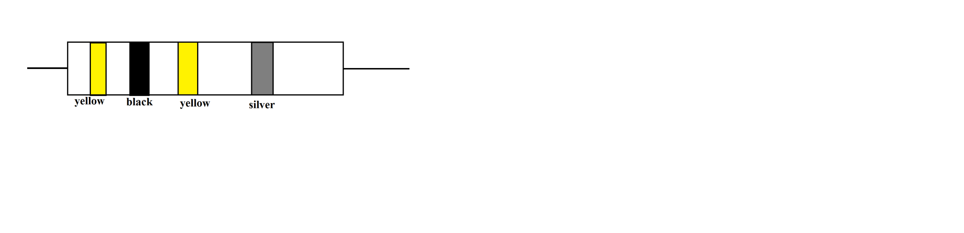
d. actual diagram /1
labelling of colours /1

5. a. – drinking straw /1
- Syringe /1
- Siphon /1
- Rubber (suction cups) suckers /1
- Vacuum cleaner /1
(any 3 points of these, 3 marks)
b. P_{l} =hdg /1
but h =$\frac{V}{A}=\frac{{27cm}^{3}}{{3cm}^{2}}$
= 9cm
= 0.09m /1
⸫ d = $\frac{Pl}{hg}$
= $\frac{900Pa}{.09m ×10N/Kg}$ /1
= 1000 Kg/m³ /1
6. a. (i) A Gamma ray /1
B. alpha particle /1
(ii) Because the particle is heavy (has mass) /1 it has a charge with low penetrating power /1
b. A_{t} = A₀ ($\frac{1}{2}$)^{T/t} /1
5 = 80 ($\frac{1}{2}$)^{24/t} /1
$\frac{1}{16}$ = ($\frac{1}{2}$)^{24/t}
($\frac{1}{2}$)⁴ = ($\frac{1}{2}$)^{24/t}
4 = $\frac{24}{t}$
t = 6 hrs /1
7. a. because its speed changes continuously as it rotates /1
b. M_{A} U_{A} + M_{B} U_{B} = (M_{A} + M_{B}) V /1
(6×12) + (20×0) = (6+20) V /1
72 = 26V
V = $\frac{72}{26}$
= 2.769 m/s or /1
= 3 m/s
c. The trapping in of energy /1 by allowing in energy of shorter wavelength /1, and converting
it to energy of longer wavelength which cannot escape /1 through the material.
8.a. Zener diode /1
b. It is connected in a reverse biased mode across the device /1 when the P.D increases beyond
limit, it breaks down and conducts/1. Thus protecting the circuit by short circuiting it /1 when
the p.d falls to normal, it returns to normal and the device conducts.
c. – Resistance of the coils /1
- eddy currents /1
- hesterisis loss /1
- flux or magnetic leakage /1
(3 marks for any 3 points)
9. a. (i) X /1
(ii) Particles in X are closely packed /1 allowing vibrations to pass quickly /1 from one particle
to the next.
b. – Virtual is formed on the same side of the screen/lens while real is formed on the other side
of the lens /1.
- virtual is erect while real is upside down (inverted) /1
- Virtual is not focussed on screen while real image is focussed on the screen /1.
(1 mark for any 1 point)

c. $\frac{1 }{f}=\frac{1}{v}+\frac{1}{u}$ /1
$\frac{1 }{10}=\frac{1}{v}+\frac{1}{15}$ /1
$\frac{1 }{v}=\frac{1}{10}+\frac{1}{15}$ /1
= $\frac{1}{30}$
V = 30cm /1
10. a. – amplitude /1
- Distance from the source /1
- frequency /1
- medium /1
(1 mark for any 1 point)
b. (i) Moves with constant velocity or maintains the same speed /1
(ii) Distance covered = Area of a triangle /1
= $\frac{1}{ 2 }$bh
= $\frac{1}{ 2 }$ ×4×20 /1
= 40m /1
c. i. B and D /1
ii. Because waves from both sources are in phase /1 causing the constructive interference
which results in maximum amplitude. /1
SECTION B
11. a.- make a sketch of two regular quadrilaterals with a pencil /1
- Draw diagonals of each quadrilateral /1
- Mark their intersection points /1
- Draw midpoint line joining the two intersection points /1
- if the midpoint is located, then the centre of mass is determined. /1
b. The two ends of a hydraulic machine are made at different surface area. /1 A small force is
applied to a smaller end /1. This force distribute pressure equally /1 in all directions to the
other end /1. Thus, a small force applied on a smaller end/ piston is multiplied to a large
force on the other end / large piston /1.
12. a. – Fill water in a can /1
- heat some water in an open /1
- remove the can from the heat /1
- Screw on its cap tightly /1
- Cool the can by running cold water over it and observe /1
b. - Take a U- shaped transparent tube and pour a liquid of known density /1
- Mark the level of the liquid in both/all arms /1
- Blow some air in one end of the manometer and record the final level in the other arm./1
- Determine the difference in height of the liquid. /1
- Calculate the lung pressure using the formula:
P_{l} = P_{A} + hdg /1
13. a. correct diagram /1. correct labels /1.
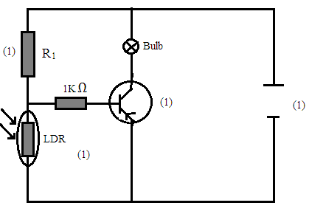

at night the resistance of LDR is higher than R₁ /1 as such, more voltage goes to the LDR resistor as it has higher resistance. /1 This makes the base voltage to increase while the base current reduces /1 hence the transistor switches on to light the bulb. /1
b. When heat is removed from a substance its temperature falls /1. This reduces the KE of the molecules /1 causing the intermolecular forces to increase /1. this makes the molecules to move slowly /1 and collide less.

